Test Case: tc002_SPX_Dev5_Crear_Requisicion_Spot_Con_FAD_Tipo_Cobro_CC
Step 1 - Enter username and password and click to button Enter : Credentials Entered
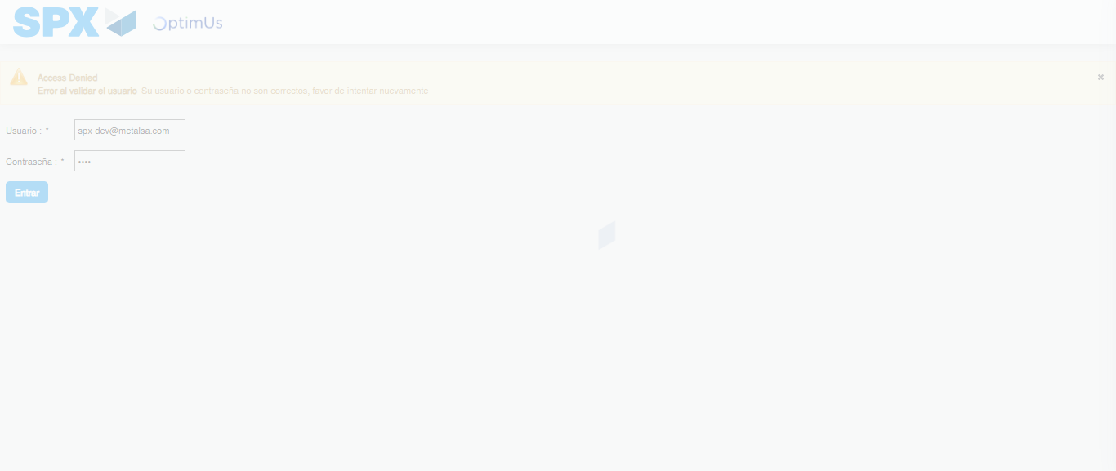Image file-name: QC_Testing-tc002_SPX_Dev5_Crear_Requisicion_Spot_Con_FAD_Tipo_Cobro_CC-1789485426263

Step 2 - Select to UEN and Access to Spot Buy Requisitions : UEN Correctly selected and Correct access
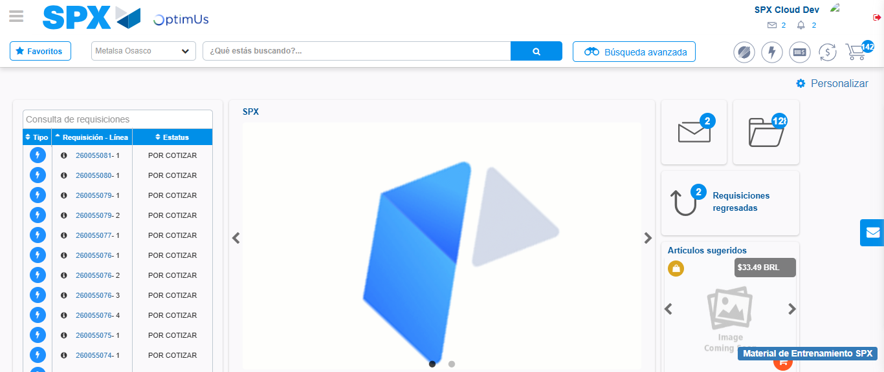Image file-name: QC_Testing-tc002_SPX_Dev5_Crear_Requisicion_Spot_Con_FAD_Tipo_Cobro_CC-1789485449707

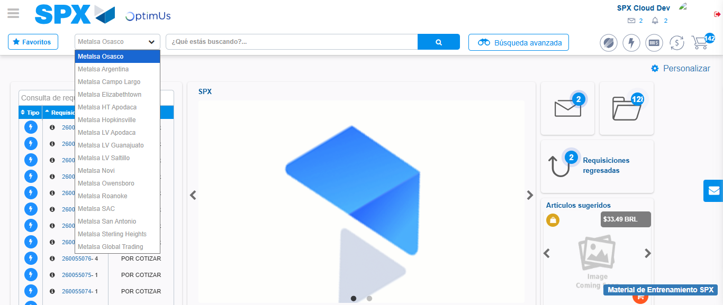Image file-name: QC_Testing-tc002_SPX_Dev5_Crear_Requisicion_Spot_Con_FAD_Tipo_Cobro_CC-1789485450305

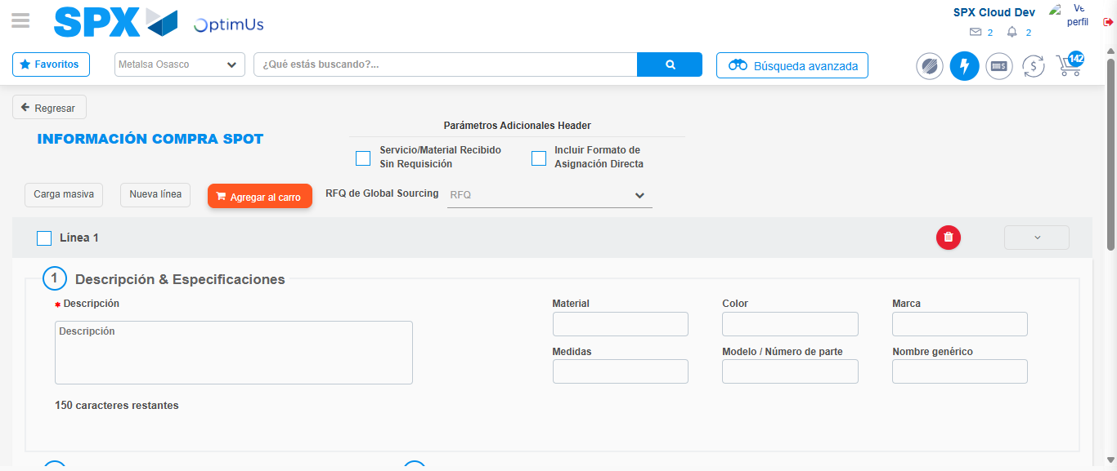Image file-name: QC_Testing-tc002_SPX_Dev5_Crear_Requisicion_Spot_Con_FAD_Tipo_Cobro_CC-1789485454916

Step 3 - Add FAD to Requisition: FAD Successfully Added
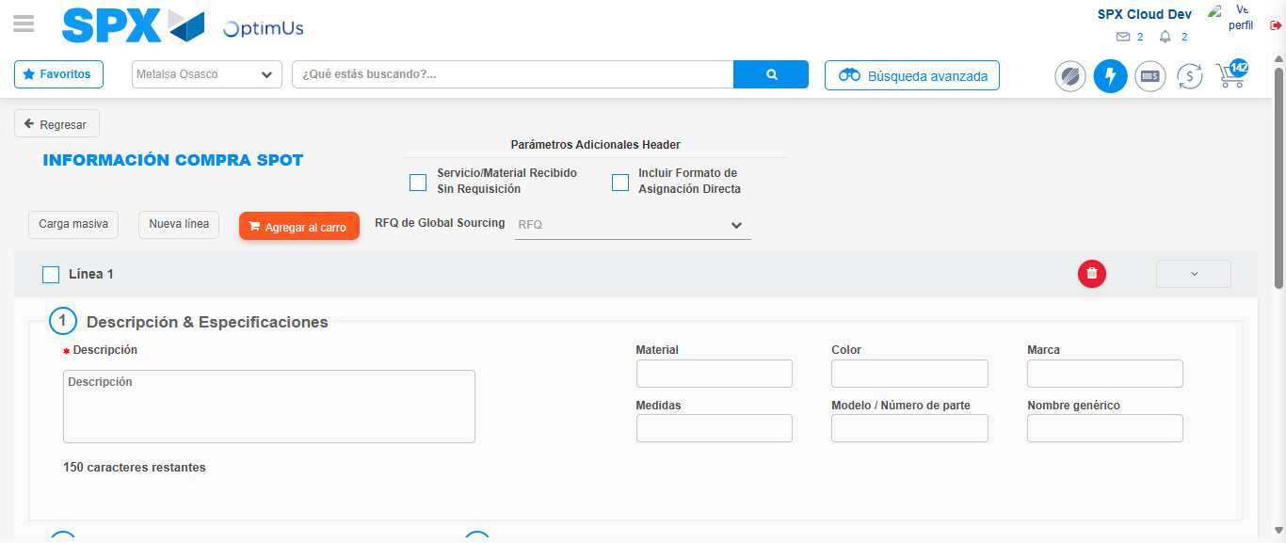Image file-name: QC_Testing-tc002_SPX_Dev5_Crear_Requisicion_Spot_Con_FAD_Tipo_Cobro_CC-1789485455247

Image file-name: QC_Testing-tc002_SPX_Dev5_Crear_Requisicion_Spot_Con_FAD_Tipo_Cobro_CC-1789485455449

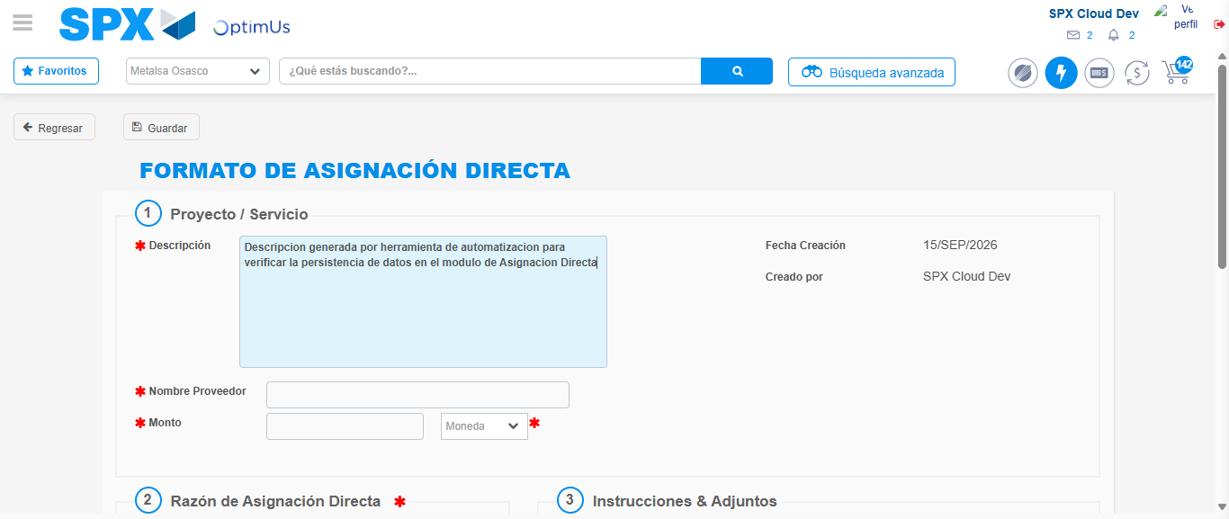Image file-name: QC_Testing-tc002_SPX_Dev5_Crear_Requisicion_Spot_Con_FAD_Tipo_Cobro_CC-1789485458362

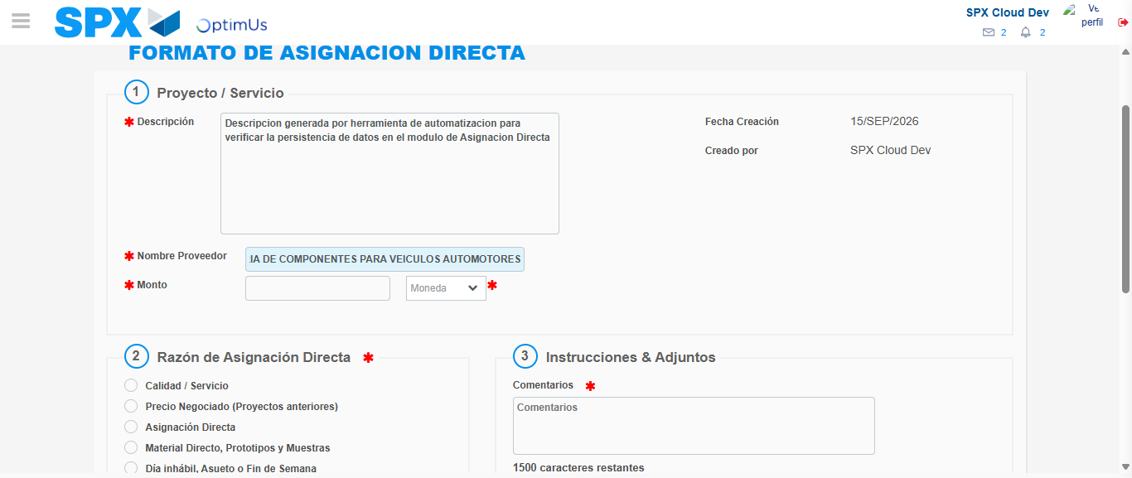Image file-name: QC_Testing-tc002_SPX_Dev5_Crear_Requisicion_Spot_Con_FAD_Tipo_Cobro_CC-1789485467874

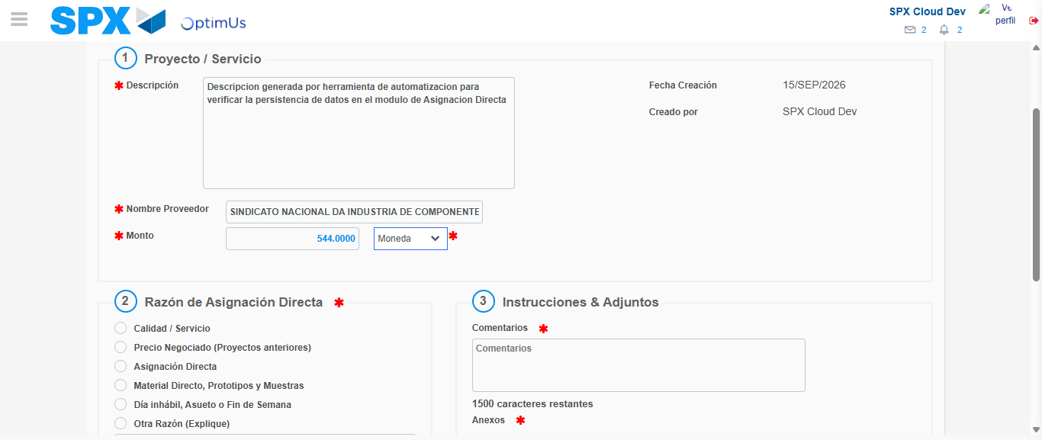Image file-name: QC_Testing-tc002_SPX_Dev5_Crear_Requisicion_Spot_Con_FAD_Tipo_Cobro_CC-1789485468400

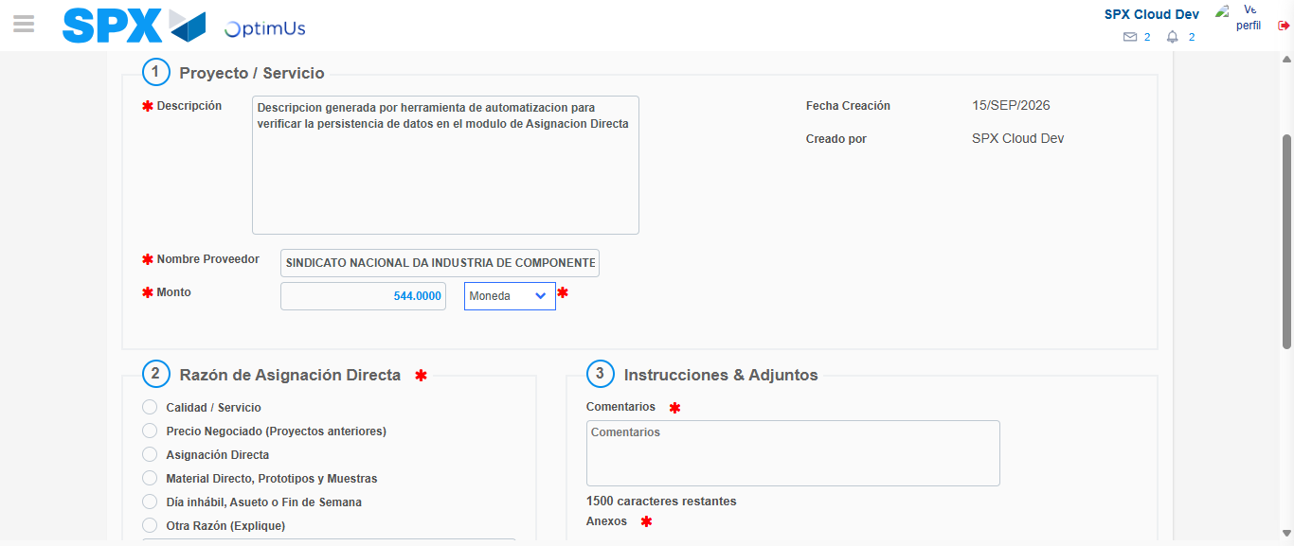Image file-name: QC_Testing-tc002_SPX_Dev5_Crear_Requisicion_Spot_Con_FAD_Tipo_Cobro_CC-1789485468640

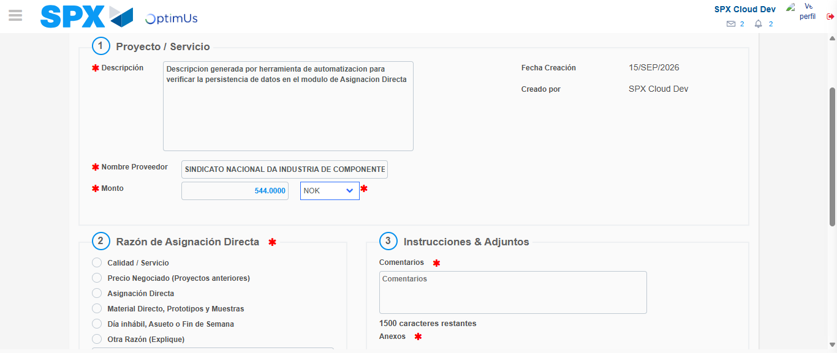Image file-name: QC_Testing-tc002_SPX_Dev5_Crear_Requisicion_Spot_Con_FAD_Tipo_Cobro_CC-1789485469041

Image file-name: QC_Testing-tc002_SPX_Dev5_Crear_Requisicion_Spot_Con_FAD_Tipo_Cobro_CC-1789485469261

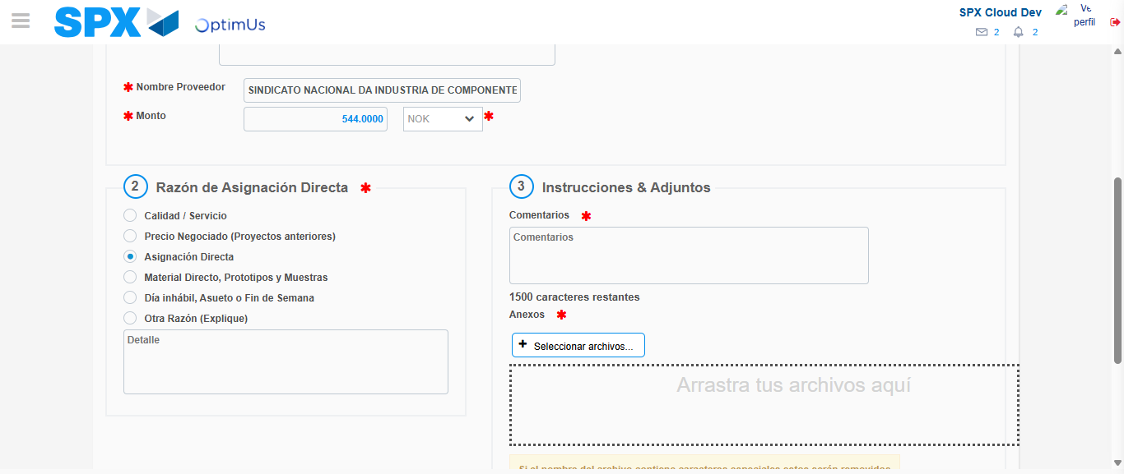Image file-name: QC_Testing-tc002_SPX_Dev5_Crear_Requisicion_Spot_Con_FAD_Tipo_Cobro_CC-1789485470104

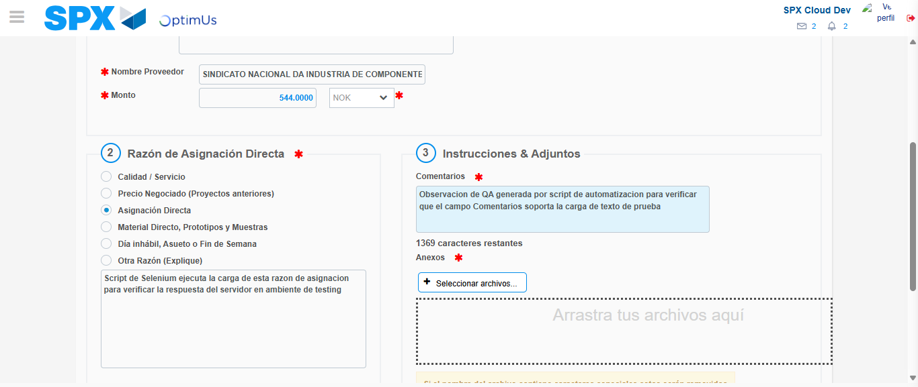Image file-name: QC_Testing-tc002_SPX_Dev5_Crear_Requisicion_Spot_Con_FAD_Tipo_Cobro_CC-1789485481380

Image file-name: QC_Testing-tc002_SPX_Dev5_Crear_Requisicion_Spot_Con_FAD_Tipo_Cobro_CC-1789485482128

Step 4 - Data Capture Spot Buy Requisition: Data captured correctly
Image file-name: QC_Testing-tc002_SPX_Dev5_Crear_Requisicion_Spot_Con_FAD_Tipo_Cobro_CC-1789485455247

Image file-name: QC_Testing-tc002_SPX_Dev5_Crear_Requisicion_Spot_Con_FAD_Tipo_Cobro_CC-1789485455449

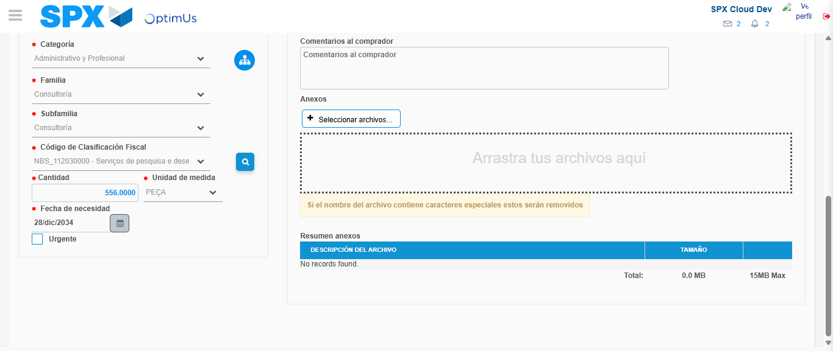Image file-name: QC_Testing-tc002_SPX_Dev5_Crear_Requisicion_Spot_Con_FAD_Tipo_Cobro_CC-1789485499886

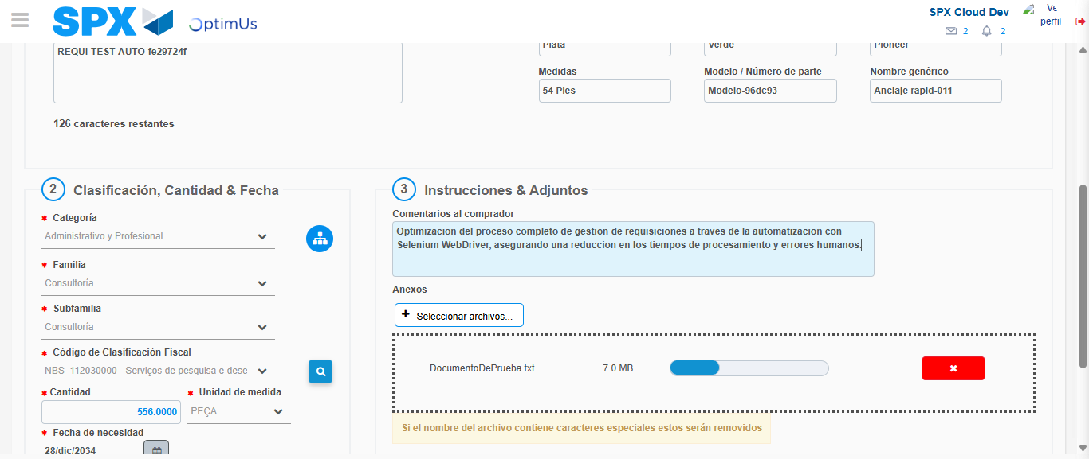Image file-name: QC_Testing-tc002_SPX_Dev5_Crear_Requisicion_Spot_Con_FAD_Tipo_Cobro_CC-1789485500852

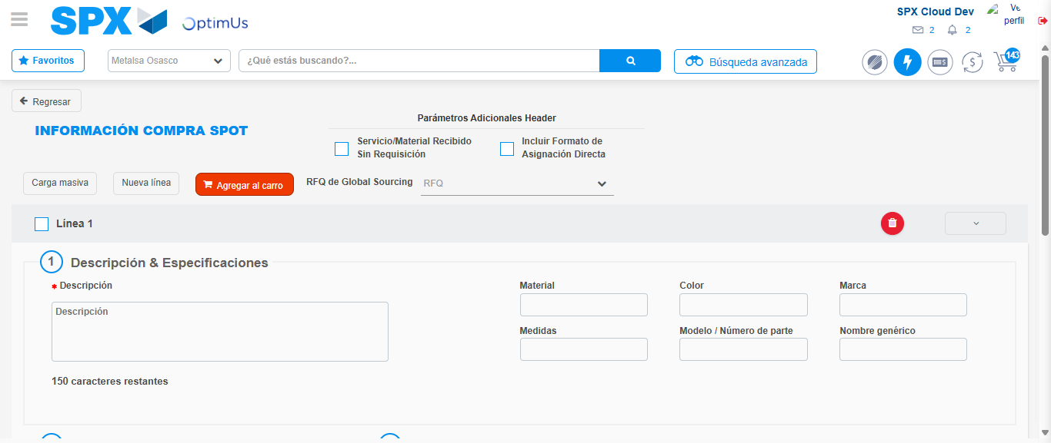Image file-name: QC_Testing-tc002_SPX_Dev5_Crear_Requisicion_Spot_Con_FAD_Tipo_Cobro_CC-1789485514231

Step 8 - Return to Main Page SPX : Return to Main Page SPX
Image file-name: QC_Testing-tc002_SPX_Dev5_Crear_Requisicion_Spot_Con_FAD_Tipo_Cobro_CC-1789485449707

Image file-name: QC_Testing-tc002_SPX_Dev5_Crear_Requisicion_Spot_Con_FAD_Tipo_Cobro_CC-1789485450305

Image file-name: QC_Testing-tc002_SPX_Dev5_Crear_Requisicion_Spot_Con_FAD_Tipo_Cobro_CC-1789485454916

Image file-name: QC_Testing-tc002_SPX_Dev5_Crear_Requisicion_Spot_Con_FAD_Tipo_Cobro_CC-1789485516462

Image file-name: QC_Testing-tc002_SPX_Dev5_Crear_Requisicion_Spot_Con_FAD_Tipo_Cobro_CC-1789485516657

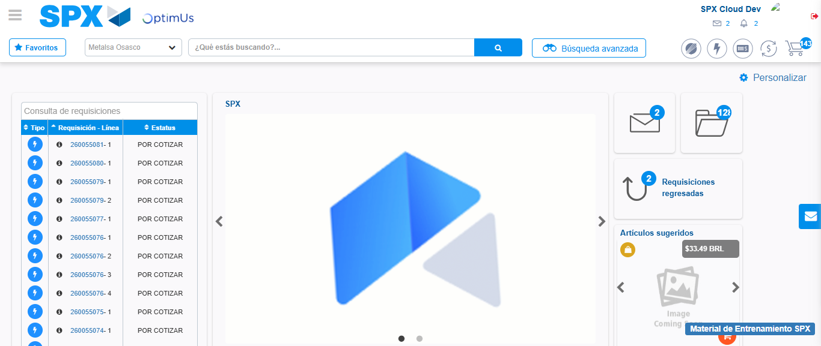Image file-name: QC_Testing-tc002_SPX_Dev5_Crear_Requisicion_Spot_Con_FAD_Tipo_Cobro_CC-1789485537866

Step 9 - Log Out : Log Out SPX
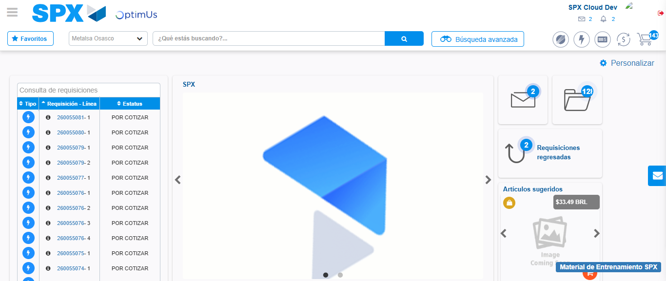Image file-name: QC_Testing-tc002_SPX_Dev5_Crear_Requisicion_Spot_Con_FAD_Tipo_Cobro_CC-1789485538181

